Unify Openscape Business Phone System (Osbiz)

CP200 TELEPHONE

Your CP200 telephone has a display to assist you. If you like the option that is highlighted, press the     key. If you want a different choice, use the → ① ②  scroll key to move to the next option.

Preprogrammed keys on your CP200 telephone:-

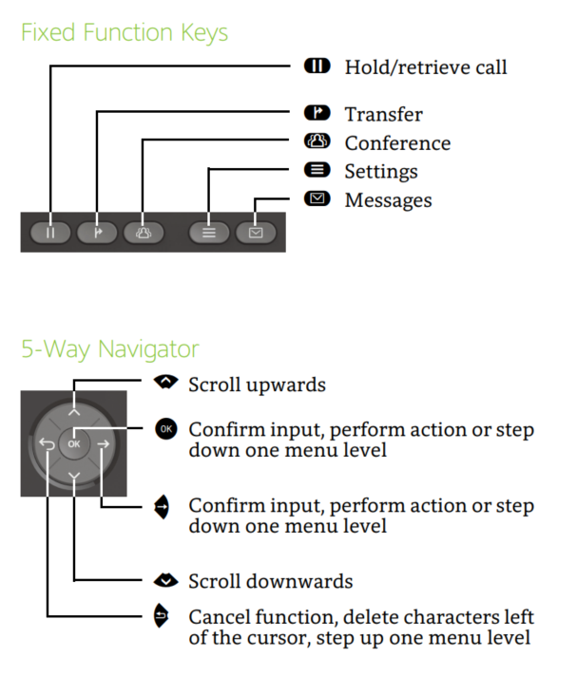
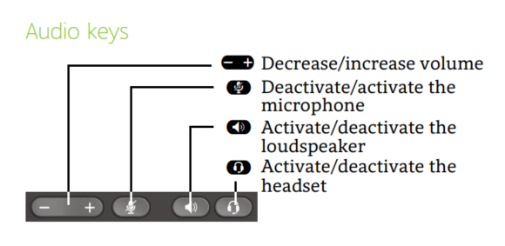

The 4 keys at the top of the phone are often programmed as:

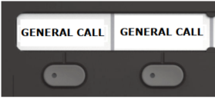 Incoming call answer and indication buttons (multiple)

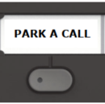 Places calls on hold in a Park position (10 locations from 0 – 9).

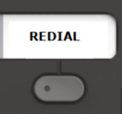 Redials the last number called (press mutliple times for 2nd last call, 3rd last etc).

FUNCTION | DESCRIPTION
Phone Settings | To change the speaker volume of the handpiece.  - Whilst in conversation, press + or – key near handpiece.  To change the ringer volume.  - With the handpiece in cradle press + button  Screen: Telephone settings  - Make sure “Ringer volume?” is highlighted on the screen.  - Press:  Press + or – key until desired volume is reached.  - Press:  to save.  To set the ringer tone.  - With the handpiece in cradle press + button.  Screen: Telephone settings  - Scroll down ②so that “Ringer tone?” is highlighted on the screen.  - Press:  - Press + or – key until desired tone is reached.  - Press:  to save.

FUNCTION | DESCRIPTION
Internal Call | Lift handset and dial the extension number you require.
External Call | Lift handset dial 0 for outside line, then dial the number you require.
Answering Calls | If the phone is ringing, lift the receiver.
To Answer more than one call. | You will have to decide whether you would like to:-  Transfer call you are attending to – refer below.  Place call on hold – refer below.  Place call in park – refer below.
(a) Transfer Call | - Make sure “Enquiry?” is highlighted on the screen.  - Press  key.  - Key in extension number.  - Press the transfer  key.  If the extension you are transferring to is busy or not answering the call, you can return to the call.  - Make sure “Return to held call?” is highlighted on the screen.  Press
(b) Hold | To put 1st caller on hold.  - Make sure “Enquiry” is highlighted on the screen.  - Press Hold key, then hang up  (Your 1st caller is on hold and 1st Line/General Call key will flash slowly).  You are now free to accept second call.  To get your 1st caller back.  - Press slow flashing Line/General Call key.
(c) Call Park | To place call in park position.  - Make sure “Enquiry” is highlighted  Press Park A Call key.  Enter and note park location (0-9). If park position number you entered is in use, enter another location.  Hang up the handset.  To retrieve a call from park position.  Press Park A Call key.  Enter park location number (0-9).
Handsfree Operation | - If speaking to caller using handpiece and you wish to use handsfree, press and hold Loudspeaker  key until you place handpiece in cradle.
FUNCTION | DESCRIPTION
Call Back | If the internal extension you are trying to reach is busy or does not answer, you can store an automatic callback.  - Make sure “Set Callback?” is highlighted on the screen.  - Press     To Cancel:  Key in #58 on keypad.  Screen: Callback : Ext no:  Make sure “Delete” is highlighted on the screen.  Press  
Programming DSS keys  (For extensions or outside numbers.) | You can program your spare keys on the phone to be DSS keys for numbers you regularly call.  - Press * then 9 then 1 and then the button you wish to configure.  - Make sure “Change feature” is highlighted on the screen.  - Press  - Make sure “Repdial key?” is highlighted on the screen.  - Press  - Dial 0 for outside line then required number, or dial extension number if using an internal number.  - Make sure “Save entry?” is highlighted on the screen.  - Press  - Make sure “End” is highlighted on the screen or scroll to Program another key.  Press
FUNCTION | DESCRIPTION
Voice Calling Announcement/  Intercom | This function allows you to issue a loudspeaker announcement to another internal extension.  Pick up handpiece.  Key in *80 on keypad.  Dial the extension number.  Speak the announcement.  The extension user hears a bleep tone followed by an announcement over the telephone loudspeaker. Extension user can reply but needs to make sure the Mute button is off (no light).
Do Not Disturb | Extension users can activate DND so that they can’t receive calls but can make calls. The main telephone should never be put into DND.  To activate  - *97.  To cancel  - #97.
Conference Calls | You are able to have a conference with several telephones at once.  - Dial required internal extension, or 0 then number for an external number.  Screen: Enquiry  - Make sure “Enquiry” is highlighted on the screen.  - Press  - Dial 2nd required internal extension, or 0 then number for an external number.  - When called party answers scroll down ② to: “Conference”.    - Press  If another party is required.  - Make sure – Conference? is highlighted on the screen.  - Press  - Make sure “Add to party” is highlighted on the screen.  - Press then dial 3rd required internal extension or 0 then number for an external number.  - When called party answers, scroll down ② to: “Conference”.    - Press
FUNCTION | DESCRIPTION
Individual Speed Dialling -  Stores 10 numbers  *0 to *9 | - Enter Code: *92  Screen: Abb. Dialing no:  - Make sure “Next” is highlighted on the screen.  - Press  Screen: *0  - Scroll down② so that “change entry” is highlighted on the screen.  - Press  Screen: *0:  - Dial 0 – for outside line, then required number.  - Make sure “Save entry” is highlighted on the screen.  - Press  Screen: *0: (number)  Make sure “Next entry” is highlighted on the screen.  - Press  Screen: *1:  - Scroll down②so that “change entry” is highlighted on the screen.  - Press  - Dial 0 – for outside line, then required number.  - Make sure “Save entry” is highlighted on the screen.  - Press  - Repeat above process until all required speed dial numbers have been entered.  To change Individual Speed Dial numbers  Enter Code *92  Screen: Abb. Dialing no:  - Make sure “Next” is highlighted on the screen.  - Press  Screen: *0: (number)  - Make sure “Next” is highlighted on the screen if *0 is not the speed dial you wish to change and Press    - Repeat the last step until you reach the speed dial you wish to change.  - Scroll down②so that “Change entry” is highlighted on the screen.  Press  Screen: *0  - Dial 0 – for outside line, then required number.  - Make sure “Save entry” is highlighted on the screen.  - Press  To quit System Administration.  Press Program/Menu Key.  To dial a number using Individual Speed Dialing.  Code *7 then speed dial code (*0 through to *9).
FUNCTION | DESCRIPTION
Group Speed Dialing –  stores numbers from 0001 to 9999 | To program group speed dials, it is necessary to start System Administration. This can only be done on the main phone.  - Enter Code *95  Screen: System Administration  user:  - Press 1.  - Press  Screen: System Administration  Ident/Password:  - Press 7436367.  - Press  Screen: System admin. -User:  11 System speed dial  12 Time  13 Date  - Make sure cursor is on 11 System speed dial.  - Press  Screen: 11 System speed dial  1 Speed dial number  2 Speed dial name  Previous menu  - Make sure cursor is on 1 Speed dial number.  - Press  Screen: 111 Abb. Speed dial number  000:  + Next  * Change  - Scroll down②to put cursor on * Change.  - Press  Screen: 111 Speed dial number  Abb dial no: 000  F3 Delete  Previous menu  - Key in 0 for outside line then required number.  - Make sure curser is on “Confirm”.  - Press  If entering more numbers:-  Screen: 111 Abb. Speed dial number  000: (number)  + Next  * Change  - Make sure curser is on “+ Next”.  - Press  - Scroll down②to put cursor on * Change.  - Press  Screen: 111 Speed dial number  Abb dial no: 001  F3 Delete  Previous menu  - Key in 0 for outside line then required number.  - Make sure curser is on “Confirm”.  - Press  - Repeat above process until all required speed dial numbers have been entered.  To quit System Administration.  Press Program/Menu Key.  To dial a number using Group Speed Dialing.  Code *7 then speed dial code (0001 through to 9999).
FUNCTION | DESCRIPTION
Call Forwarding/  Divert | You can call forward your phone to another telephone.  - With the handpiece in the cradle press the * key then 1  Screen: Diversion type: 1 = all calls  2 = only external calls  3 = only internal calls  End  - If you want to forward all calls make sure “1=all calls” is highlighted or scroll down②so that your choice is highlighted on the screen.  - Press  Screen: all to:  - Key in the extension number that calls are to be diverted to.  Screen: all to: (number)  - Make sure “Save entry” is highlighted on the screen.  - Press  To cancel Call Forwarding/Diversion  - With the handpiece in the cradle press dial # then 1
Change Time | You can change the system time and date but only on the main telephone.  - Enter Code *95  Screen: System Administration  User:  - Press 1.  - Press    Screen: System Administration  Indent Password:  - Press 7436367  - Press    Screen: System admin – User:  11 System speed dial  12 Time  13 Date  - Scroll down②to put cursor on “12 Time”.  - Press  Screen: 12 Time  Format: hhmm:  - Make sure the cursor is on “* Change”.  - Press  Screen: 12 Time  Format hhmm:  - Key in correct time in 24 hour format.  - Make sure the cursor is on “Confirm”.  - Press  To quit System Administration.  Press Program/Menu Key.
FUNCTION | DESCRIPTION
Call Transfer to  Network  (Note: This function needs to be programmed by a SATELCO Technician) | You can transfer a call to an external number.  Screen: Enquiry  - Press  - Press a DSS key if one has been programmed for the required number, or dial 0 for outside line then required number.  - Wait for the person to answer.  - Press key.  The call has now been transferred.  If the person you were ringing does not answer and you wish to return to the caller:  - Make sure “Return to held call” is highlighted on the screen.  - Press  You are now connected to your original caller.
Group Pick Up  (Note: Pickup groups can be programmed by a SATELCO Technician) | If your extension is in a Pickup Group you can pick up calls for other extensions in your group.  Screen: Call for:  Pickup – Group  - Press
Quick Reference Guide for Feature Codes  Speed Number Dialling  Call Forwarding  Voicecall/Intercom  Programming DSS keys  Speed Number Programming  Call Pick Up – Group  Call Pick Up – Direct  Clear unknown feature on extension  Set Time and date  Enable Call Waiting | Individual *7 then library number *0 to *9  Group *7 then library number 000 to 999  *11  *80 then individual extension  *91  Individual *92  Group *95  *57  *59 then ringing extension number  Lift handset #0  *95 user 1 / password 1 (only on main phone)  #87 - *87 to disable

