Unify Openscape Business Phone System (Osbiz)

CP400 TELEPHONE

Your CP400 telephone has a display to assist you. If you like the option that is highlighted, press the     key. If you want a different choice, use the → ① ②  scroll key to move to the next option.

Preprogrammed keys on your CP400 telephone:-

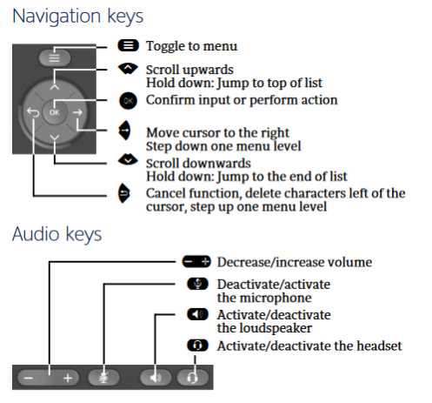
The 16 keys on the side of the phone are programmed as:-

Incoming call answer and indication buttons (multiple)
or

Keys not programmed or configured as quick dial (DSS) Keys

Places answered call on hold.

Places calls on hold in a Park position.
10 locations from 0 – 9.

Disconnects the call

FUNCTION | DESCRIPTION
Phone Settings | To change the speaker volume of the handpiece.  - Whilst in conversation, press + or – key near handpiece.  To change the ringer volume.  - With the handpiece in cradle press + button  Screen: Telephone settings  - Make sure “Ringer volume” is highlighted on the screen.  - Press:  Press + or – key until desired volume is reached.  - Press:  to save.  To set the ringer tone.  - With the handpiece in cradle press + button.  Screen: Telephone settings  - Scroll down ②so that “Ringer tone is highlighted on the screen.  - Press:  - Press + or – key until desired tone is reached.  - Press:  to save.

FUNCTION | DESCRIPTION
Internal Call | Lift handset and dial the extension number you require, or use DSS (Direct Station Selection) key.
External Call | Lift handset dial 0 for outside line, then dial the number you require.
Answering Calls | If the phone is ringing, lift the receiver.
To Answer more than one call. | You will have to decide whether you would like to:-  Transfer call you are attending to – refer below.  Place call on hold – refer below.  Place call in park – refer below.
(a) Transfer Call | - Make sure “Enquiry” is highlighted on the screen.  - Press  key.  - Key in extension number, or use DSS key.  - Press key.  If the extension you are transferring to is busy or not answering the call, you can return to the call.  - Make sure “Return to held call” is highlighted on the screen.  Press
(b) Hold | To put 1st caller on hold.  - Make sure “Enquiry” is highlighted on the screen.  - Press Hold key, then press key.  (Your 1st caller is on hold and 1st Line key will flash slowly).  You are now free to accept second call.  To get your 1st caller back.  - Press slow flashing Line key.
(c) Call Park | To place call in park position.  - Make sure “Enquiry” is highlighted  Press Park A Call key.  Enter and note park location (0-9). If park position number you entered is in use, enter another location.  Press key.  To retrieve a call from park position.  Press Park A Call key.  Enter park location number (0-9).
Handsfree Operation | - If speaking to caller using handpiece and you wish to use handsfree, press and hold Loudspeaker key until you place handpiece in cradle.
FUNCTION | DESCRIPTION
Call Back | If the internal extension you are trying to reach is busy or does not answer, you can store an automatic callback.  - Make sure “Set Callback” is highlighted on the screen.  - Press     To Cancel:  Key in #58 on keypad.  Screen: Callback : Ext no:  Make sure “Delete” is highlighted on the screen.  Press    
Programming DSS keys  (For extensions or outside numbers.) | You can program your spare keys on the phone to be DSS keys for numbers you regularly call.  - Press and hold the button you wish to configure.  Screen: 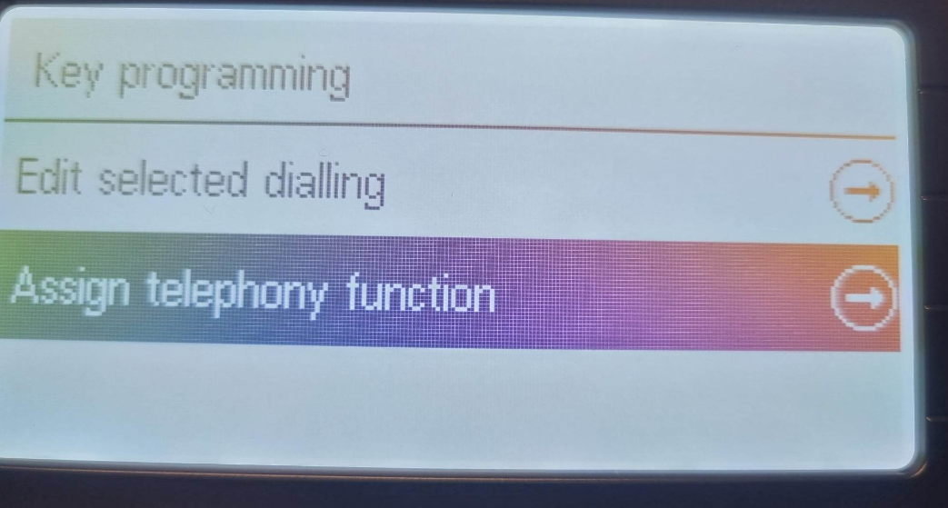  - Scroll to Assign Telephony function and Press OK  Screen: 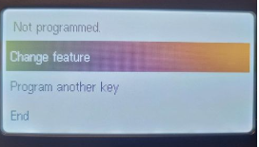  - Make sure “Change feature” is highlighted on the screen.  - Press  Screen: 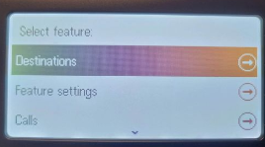  - Make sure “Destinations” is highlighted on the screen.  - Press  Screen: 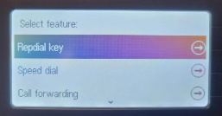  - Make sure “Repdial Key” is highlighted on the screen.  - Press  Screen: 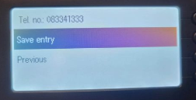  - Dial 0 for outside line then required number, or dial extension number if using an internal number.  - Make sure “Save entry” is highlighted on the screen.  - Press  Screen: 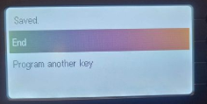  - Make sure “End” is highlighted on the screen or scroll to Program another key.  Press
FUNCTION | DESCRIPTION
Voice Calling Announcement/  Intercom | This function allows you to issue a loudspeaker announcement to another internal extension.  Pick up handpiece.  Key in *80 on keypad.  Dial the extension number.  Speak the announcement.  The extension user hears a bleep tone followed by an announcement over the telephone loudspeaker. Extension user can reply but needs to make sure the Mute button is off (no light).
Do Not Disturb | Extension users can activate DND so that they can’t receive calls but can make calls. The main telephone should never be put into DND.  To activate  - *97.  To cancel  - #97.
Conference Calls | You are able to have a conference with several telephones at once.  - Dial required internal extension, or 0 then number for an external number.  Screen: Enquiry  - Make sure “Enquiry” is highlighted on the screen.  - Press  - Dial 2nd required internal extension, or 0 then number for an external number.  - When called party answers scroll down ② to: “Conference”.    - Press  If another party is required.  - Make sure – Conference is highlighted on the screen.  - Press  - Make sure “Add to party” is highlighted on the screen.  - Press then dial 3rd required internal extension or 0 then number for an external number.  - When called party answers, scroll down ② to: “Conference”.    - Press
FUNCTION | DESCRIPTION
Individual Speed Dialing -  Stores 10 numbers  *0 to *9 | - Enter Code: *92  Screen: Abb. Dialing no:  - Make sure “Next” is highlighted on the screen.  - Press  Screen: *0  - Scroll down② so that “change entry” is highlighted on the screen.  - Press  Screen: *0:  - Dial 0 – for outside line, then required number.  - Make sure “Save entry” is highlighted on the screen.  - Press  Screen: *0: (number)  Make sure “Next entry” is highlighted on the screen.  - Press  Screen: *1:  - Scroll down②so that “change entry” is highlighted on the screen.  - Press  - Dial 0 – for outside line, then required number.  - Make sure “Save entry” is highlighted on the screen.  - Press  - Repeat above process until all required speed dial numbers have been entered.  To change Individual Speed Dial numbers  Enter Code *92  Screen: Abb. Dialing no:  - Make sure “Next” is highlighted on the screen.  - Press  Screen: *0: (number)  - Make sure “Next” is highlighted on the screen if *0 is not the speed dial you wish to change and Press    - Repeat the last step until you reach the speed dial you wish to change.  - Scroll down②so that “Change entry” is highlighted on the screen.  Press  Screen: *0  - Dial 0 – for outside line, then required number.  - Make sure “Save entry” is highlighted on the screen.  - Press  To quit System Administration.  Press Program/Menu Key.  To dial a number using Individual Speed Dialing.  Code *7 then speed dial code (*0 through to *9).
FUNCTION | DESCRIPTION
Group Speed Dialing –  stores numbers from 0001 to 9999 | To program group speed dials it is necessary to start System Administration. This can only be done on the main phone.  - Enter Code *95  Screen: System Administration  user:  - Press 1.  - Press  Screen: System Administration  Ident/Password:  - Press 1.  - Press  Screen: System admin. -User:  11 System speed dial  12 Time  13 Date  - Make sure cursor is on 11 System speed dial.  - Press  Screen: 11 System speed dial  1 Speed dial number  2 Speed dial name  Previous menu  - Make sure cursor is on 1 Speed dial number.  - Press  Screen: 111 Abb. Speed dial number  000:  + Next  * Change  - Scroll down②to put cursor on * Change.  - Press  Screen: 111 Speed dial number  Abb dial no: 000  F3 Delete  Previous menu  - Key in 0 for outside line then required number.  - Make sure curser is on “Confirm”.  - Press  If entering more numbers:-  Screen: 111 Abb. Speed dial number  000: (number)  + Next  * Change  - Make sure curser is on “+ Next”.  - Press  - Scroll down②to put cursor on * Change.  - Press  Screen: 111 Speed dial number  Abb dial no: 001  F3 Delete  Previous menu  - Key in 0 for outside line then required number.  - Make sure curser is on “Confirm”.  - Press  - Repeat above process until all required speed dial numbers have been entered.  To quit System Administration.  Press Program/Menu Key.  To dial a number using Group Speed Dialing.  Code *7 then speed dial code (000 through to 999).
FUNCTION | DESCRIPTION
Call Forwarding/  Divert | You can call forward your phone to another telephone.  - With the handpiece in the cradle press the * key then 1  Screen: Diversion type: 1 = all calls  2 = only external calls  3 = only internal calls  End  - If you want to forward all calls make sure “1=all calls” is highlighted or scroll down②so that your choice is highlighted on the screen.  - Press  Screen: all to:  - Key in the extension number that calls are to be diverted to.  Screen: all to: (number)  - Make sure “Save entry” is highlighted on the screen.  - Press  To cancel Call Forwarding/Diversion  - With the handpiece in the cradle press dial # then 1
Change Time | You can change the system time and date but only on the main telephone.  - Enter Code *95  Screen: System Administration  User:  - Press 1.  - Press    Screen: System Administration  Indent Password:  - Press 7436367  - Press    Screen: System admin – User:  11 System speed dial  12 Time  13 Date  - Scroll down②to put cursor on “12 Time”.  - Press  Screen: 12 Time  Format: hhmm:  - Make sure the cursor is on “* Change”.  - Press  Screen: 12 Time  Format hhmm:  - Key in correct time in 24 hour format.  - Make sure the cursor is on “Confirm”.  - Press  To quit System Administration.  Press Program/Menu Key.
FUNCTION | DESCRIPTION
Call Transfer to  Network  (Note: This function needs to be programmed by a SATELCO Technician) | You can transfer a call to an external number.  Screen: Enquiry  - Press  - Press a DSS key if one has been programmed for the required number, or dial 0 for outside line then required number.  - Wait for the person to answer.  - Press key.  The call has now been transferred.  If the person you were ringing does not answer and you wish to return to the caller:  - Make sure “Return to held call” is highlighted on the screen.  - Press  You are now connected to your original caller.
Group Pick Up  (Note: Pickup groups can be programmed by a SATELCO Technician) | If your extension is in a Pickup Group you can pick up calls for other extensions in your group.  Screen: Call for:  Pickup – Group  - Press
Quick Reference Guide for Feature Codes  Speed Number Dialling  Call Forwarding  Voicecall/Intercom  Programming DSS keys  Speed Number Programming  Call Pick Up – Group  Call Pick Up – Direct  Clear unknown feature on extension  Set Time and date  Enable Call Waiting | Individual *7 then library number *0 to *9  Group *7 then library number 000 to 999  *11  *80 then individual extension  *91  Individual *92  Group *95  *57  *59 then ringing extension number  Lift handset #0  *95 user 1 / password 1 (only on main phone)  #87 - *87 to disable

